**ASSIGNMENT-13**

**EMPLOYEE ID:** 46248061.

**QUESTION 1: Inline declarations.**

**PROGRAME NAME:** Z8061_DAY13_1.

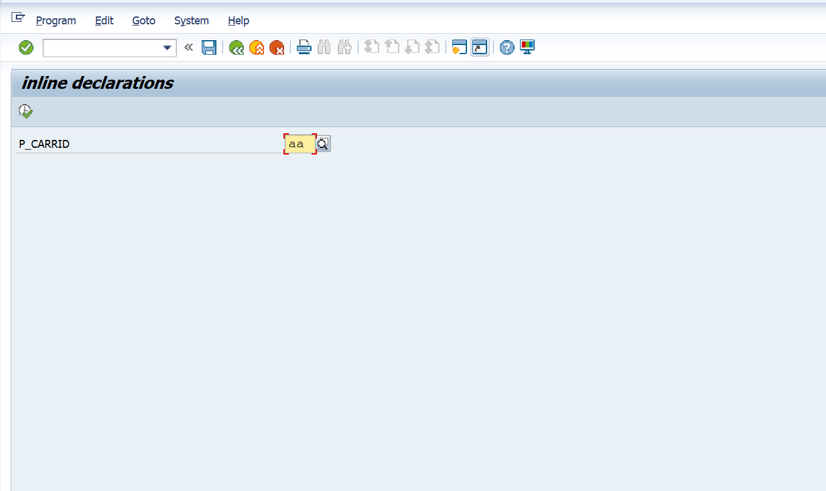

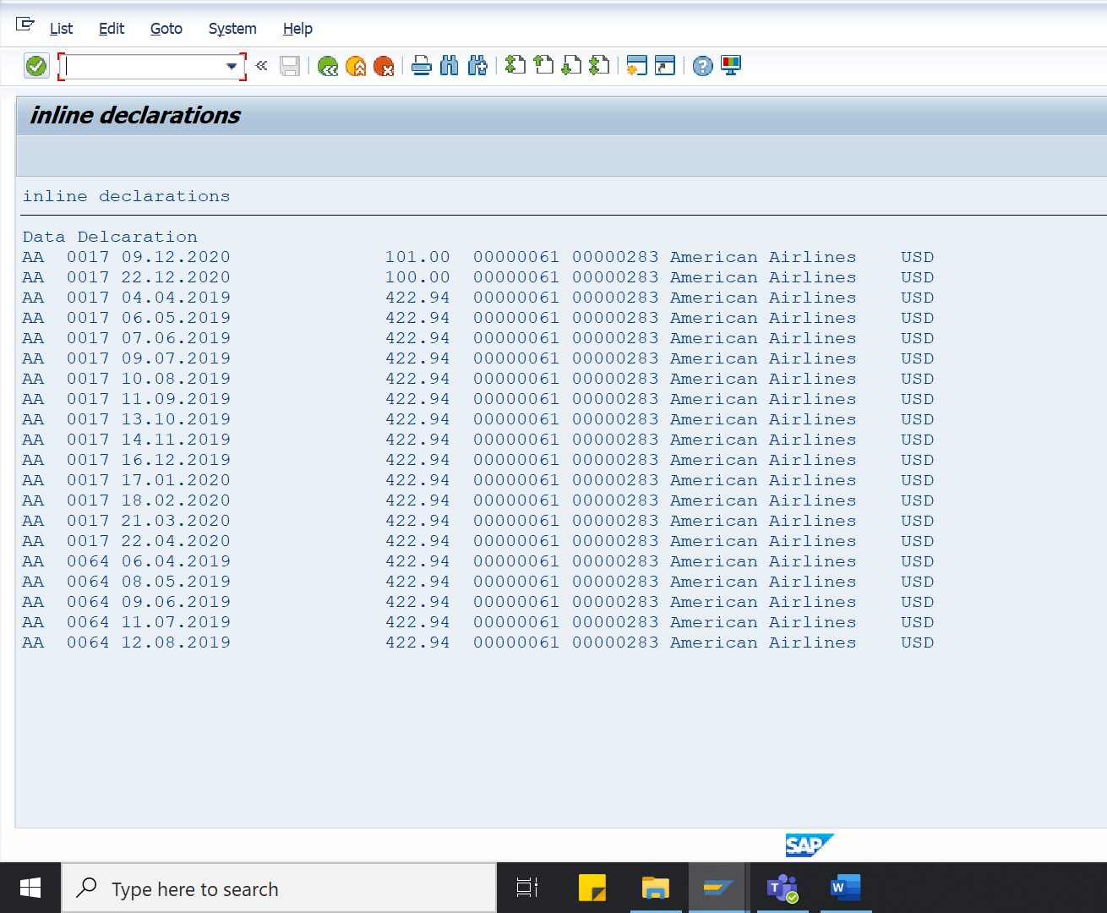

**QUESTION 2: Table Expressions.**

**PROGRAME NAME:** Z8061_DAY13_2.

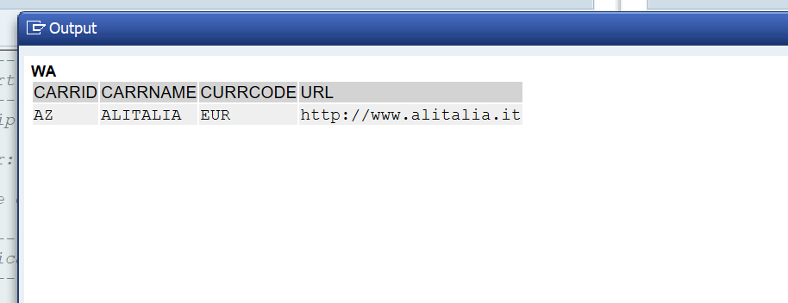

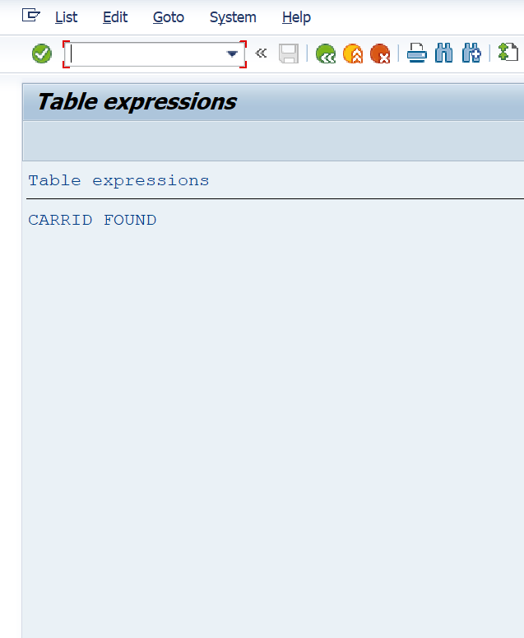

**QUESTION 3: conversion operator.**

**PROGRAME NAME:** Z8061_DAY13_3.

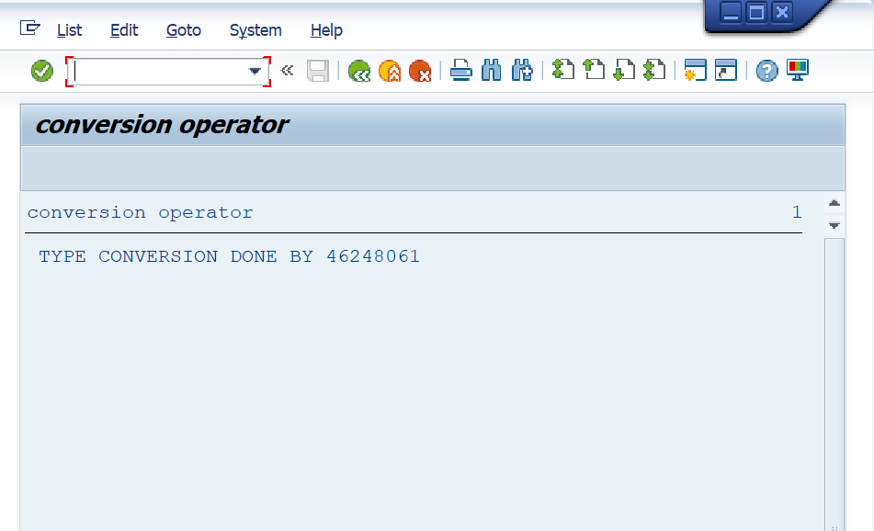

**QUESTION 4: value operator.**

**PROGRAME NAME:** Z8061_DAY13_4.

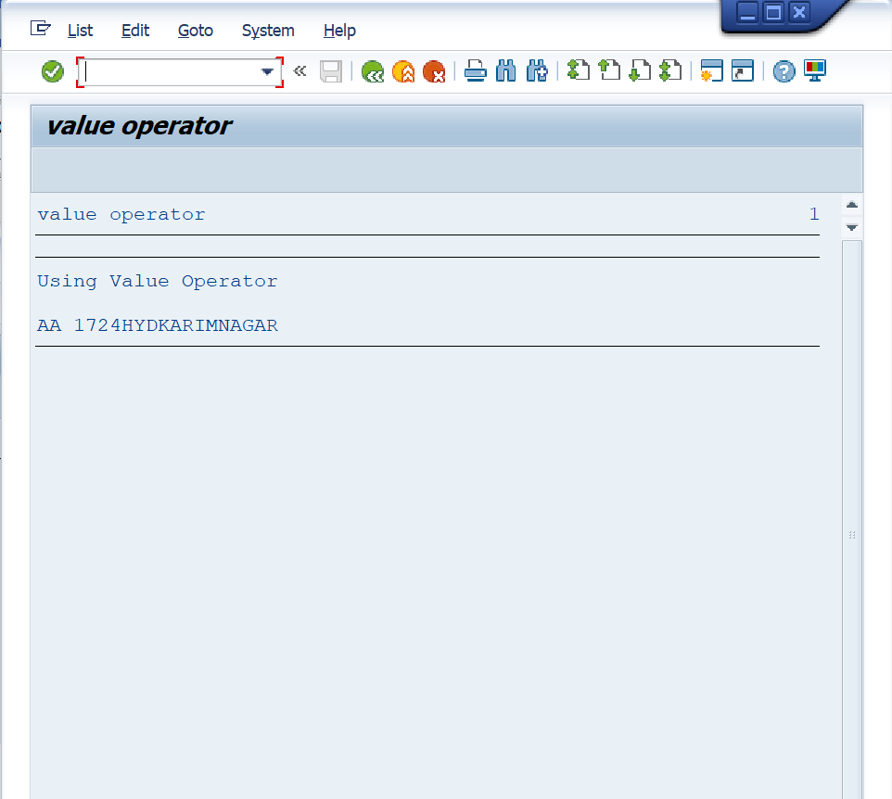

**QUESTION 5: for operator.**

**PROGRAME NAME:** Z8061_DAY13_5.

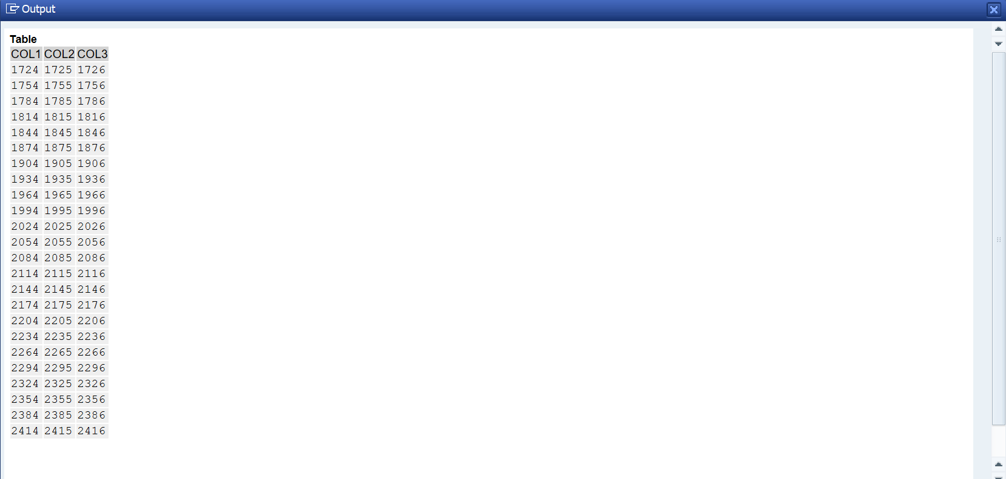

**QUESTION 6: Reduction operator.**

**PROGRAME NAME:** Z8061_DAY13_6.

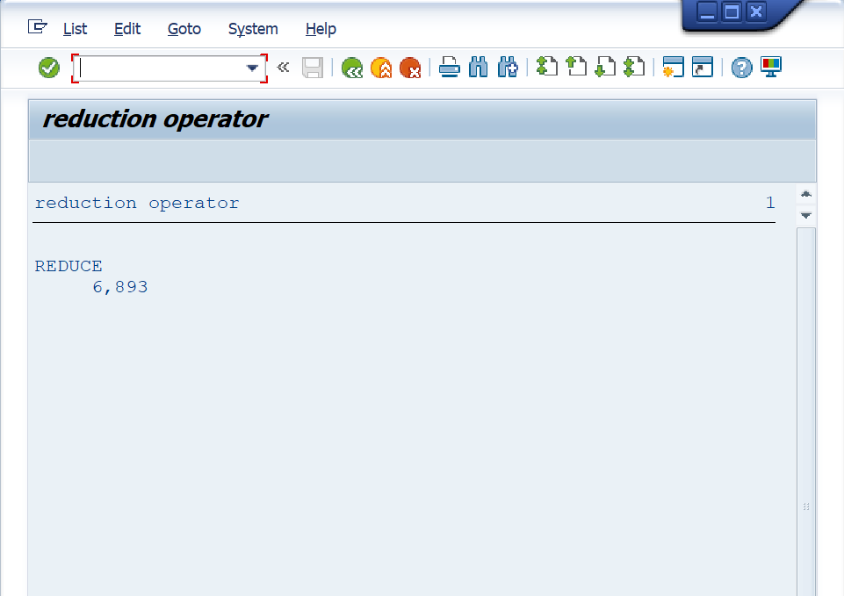

**QUESTION 7: Conditional operators.**

**PROGRAME NAME:** Z8061_DAY13_7.

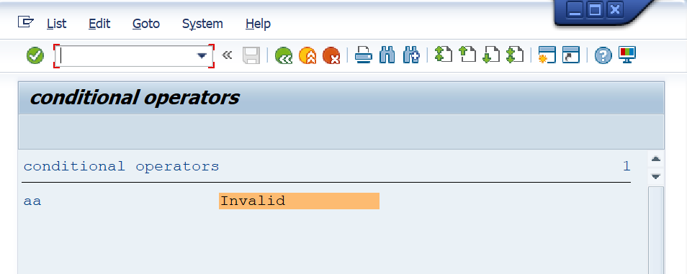

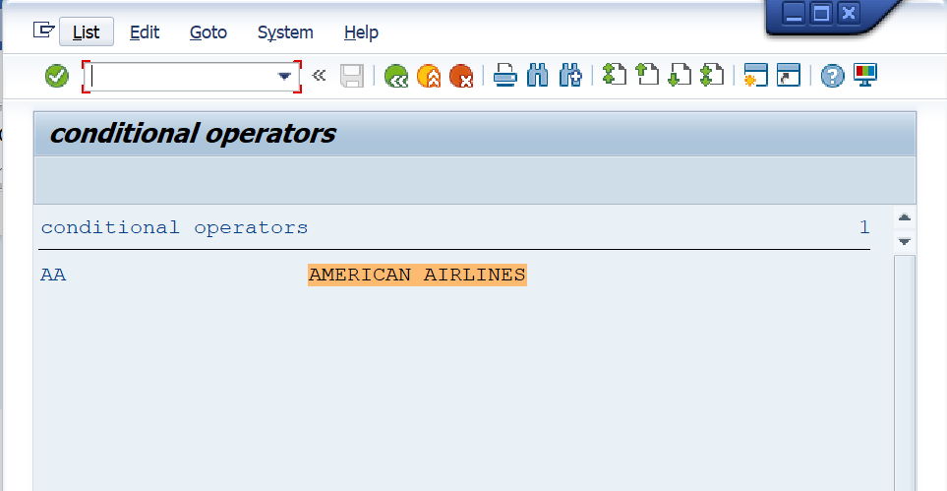

**QUESTION 8: corresponding operator.**

**PROGRAME NAME:** Z8061_DAY13_8.

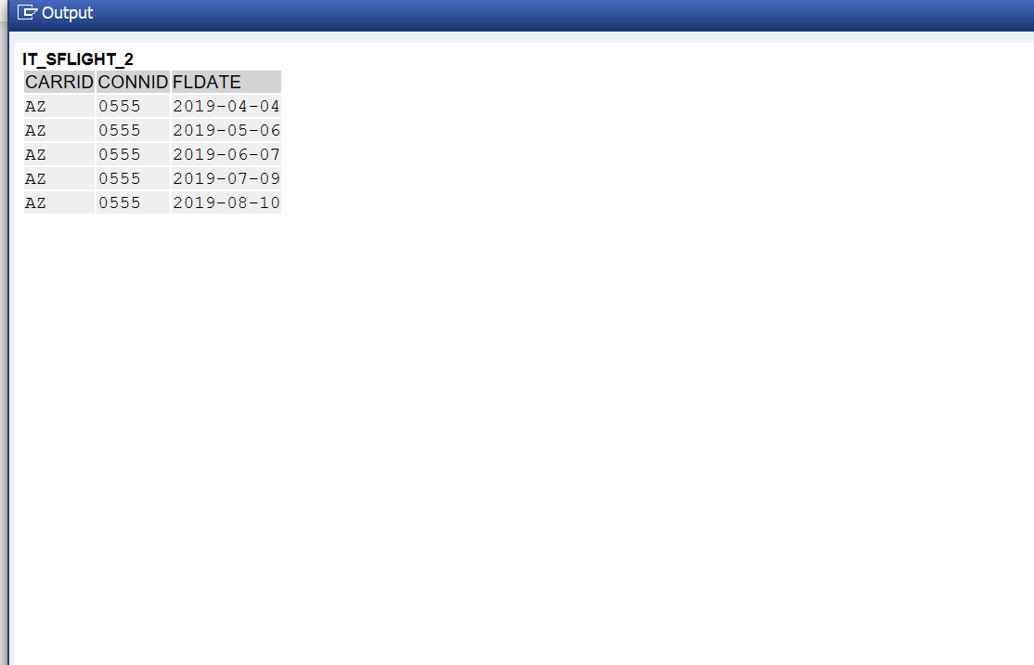

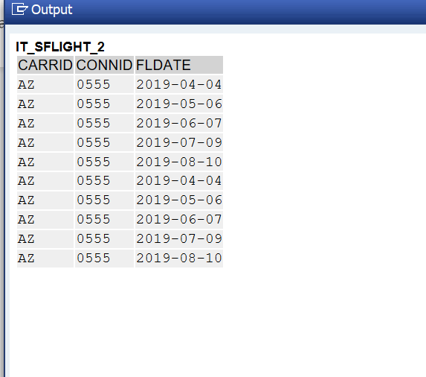

**QUESTION 9: Strings.**

**PROGRAME NAME:** Z8061_DAY13_9.

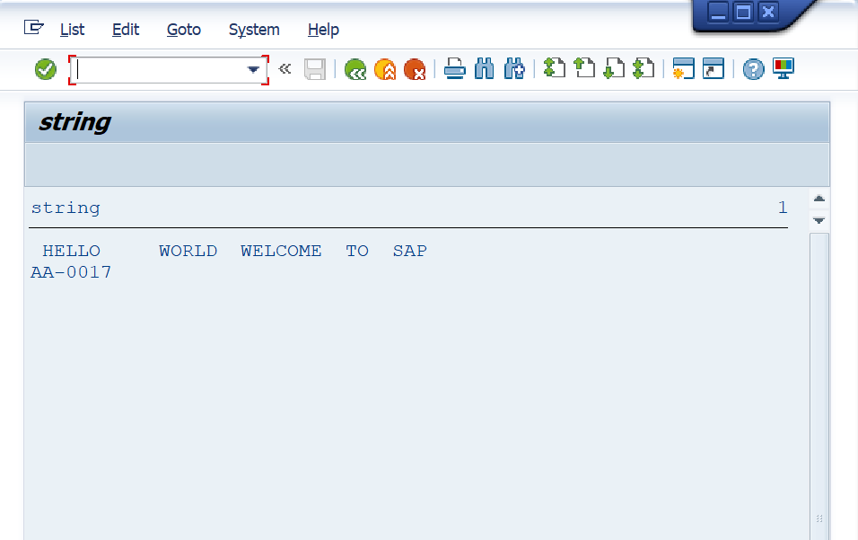

**QUESTION 10: loop at group by.**

**PROGRAME NAME:** Z8061_DAY13_10.

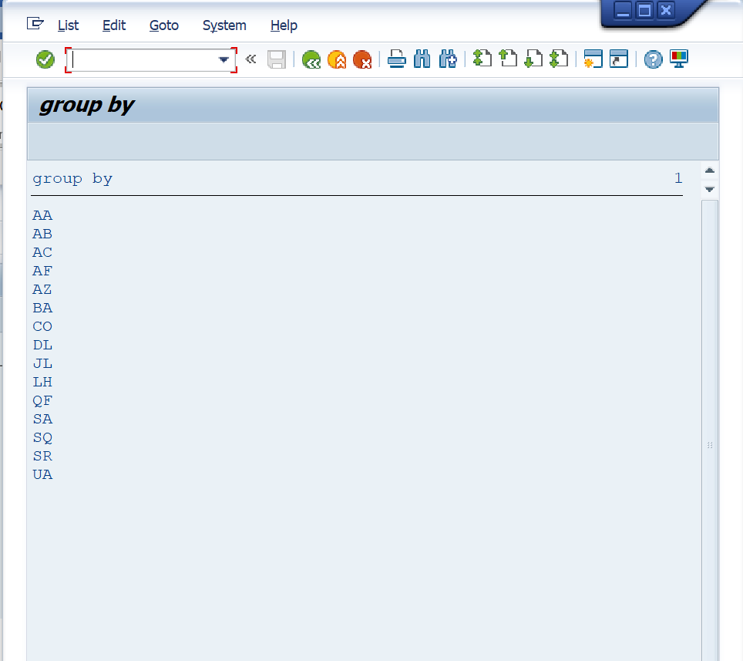

**QUESTION 11: classes and methods**

**PROGRAME NAME:** Z8061_DAY13_11.

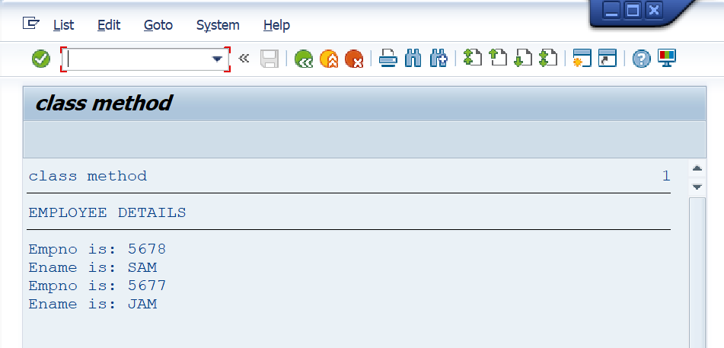

**QUESTION 12: meshes.**

**PROGRAME NAME:** Z8061_DAY13_12.

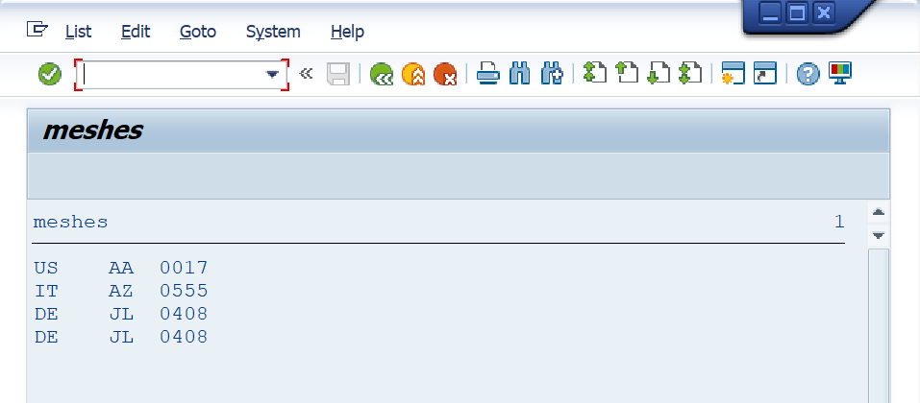

**QUESTION 13: filter.**

**PROGRAME NAME:** Z8061_DAY13_13.

